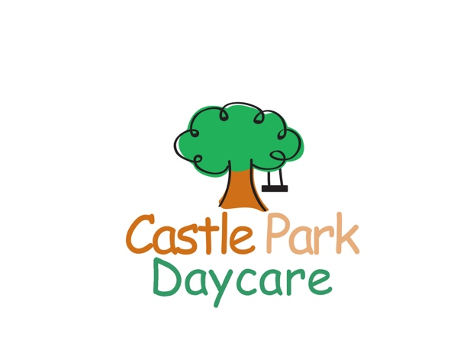
Activity Camp 2024
9am-4pm
Ages 6 and up
www.castleparkdaycare.ca
416 691-5211
1971 Queen St. E. Suite 102, Toronto, Ontario M4L 1H9

Camper’s First Name: _______________________________ Last Name _________________________M ____ F

Birth date: _____/__________/_________ grade _______ School: __________________________________________

Address: _________________________________________________________________________________________
Street City Postal Code

Parent Name: _________________________________________________Cell # (______)____________________

Work: ( ________)_______________________ e-mail ___________________________________________________

Emergency contact: __________________________________________ Relationship: __________________________

Work #: (_____)__________________________________ Cell #: (______)____________________________________

Authorized pick up: 1) ___________________________________ Relationship: ________________________________

2) ___________________________________ Relationship: ________________________________

Allergies: ________________________________________________________________________________________
Please fill out anaphylactic form if needed (please ask staff)

Physician’s name:______________________________________ Phone # :_______________________________

Health card #: ________________________________________________
Week 1 |  | Week 2 |  | Week 3 | Week 4 | Week 5 |  | Week 6 |  | Week 7 |  | Week 8 |  | Week 9
Science |  | Arts and craft |  | Outdoor Adventure | Lego | Water Fun |  | Sports Camp |  | Creative Drama |  | Active Kids |  | Let’s have fun
July 2-5 | July 8-12 |  | July 15-19 |  | July 22-26 | July 29-  Aug.-2 | Aug.6-9 |  | Aug 12-16 |  | Aug.19-23 |  | Aug.26-30
$180* | $230 |  | $230 |  | $230 | $230 | $180* |  | $230 |  | $230 |  | $230
* | * |  | * |  | * | * | * * |  | * |  | * |  | *

*extended care is available for $50/week until 6pm. Please indicate with a 2nd check mark.

Payment: $50 non-refundable deposit required with registration and remaining balance due by July 1st. Pay by cash, cheque or e-transfer. Please make cheque payable to: Ella Dembeck E-mail for e-transfer: edembeck22@gmail.com. Make sure you mention your child’s name in the e-transfer!

I have included: cash Cheque e-transfer

Amount: $ _____________________

